**HR Database SQL Project**

**1. Retrieve all details of employees**

**-SELECT * FROM employees;**

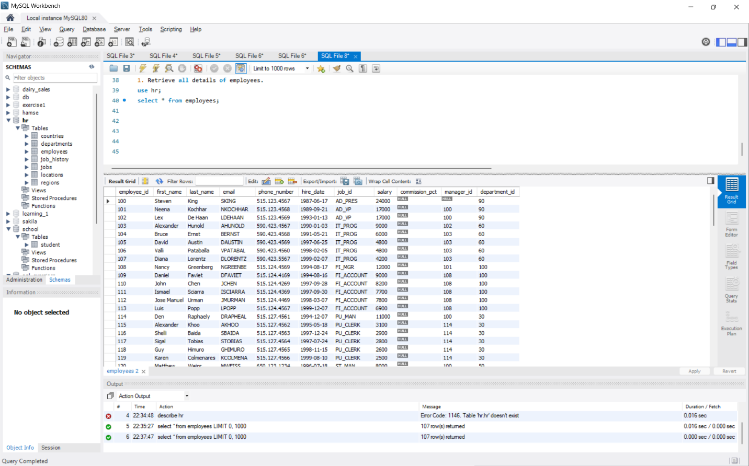

**2. Display first name, last name, and email of all employees**

**-SELECT first_name, last_name, email FROM employees;**

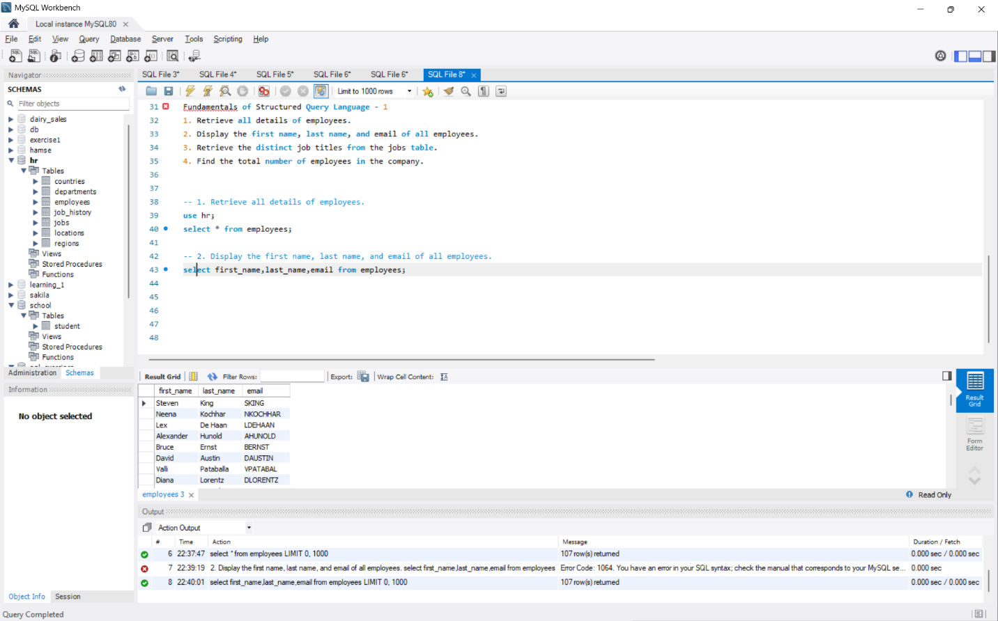

**3. Retrieve the distinct job titles from the jobs table**

**-SELECT DISTINCT job_title FROM jobs;** 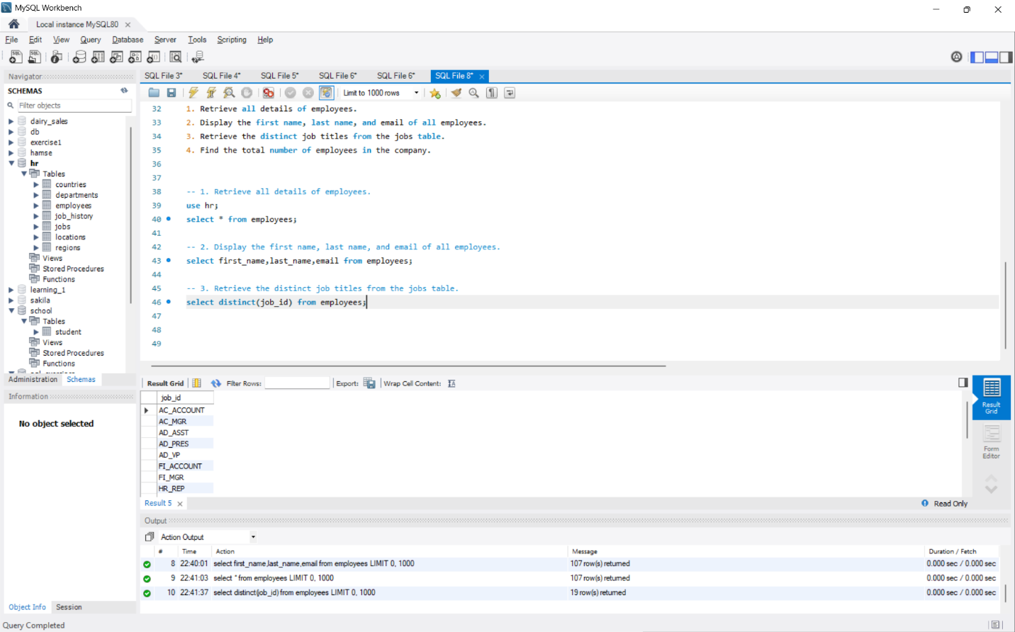

**4. Find the total number of employees**

**-SELECT COUNT(*) AS total_employees FROM employees;**

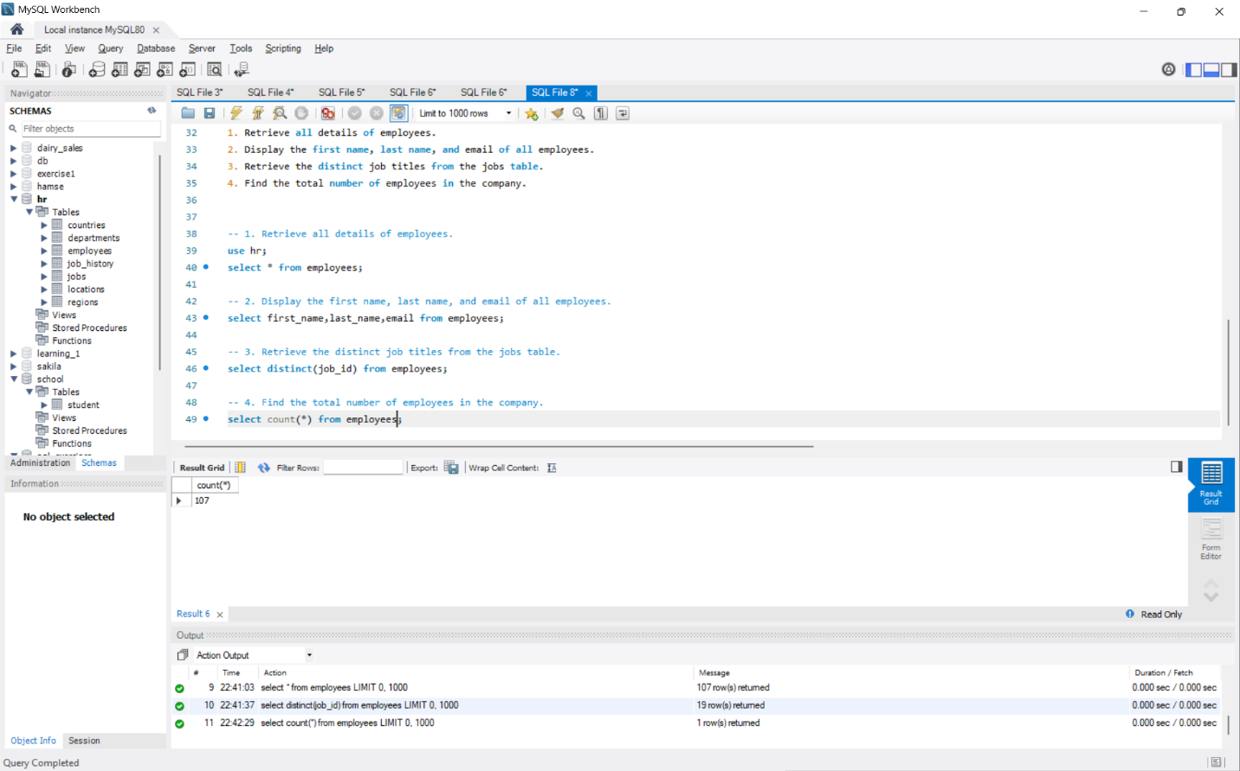

**5. Retrieve employees hired after January 1, 2015**

**-SELECT * FROM employees WHERE hire_date > '2015-01-01';**

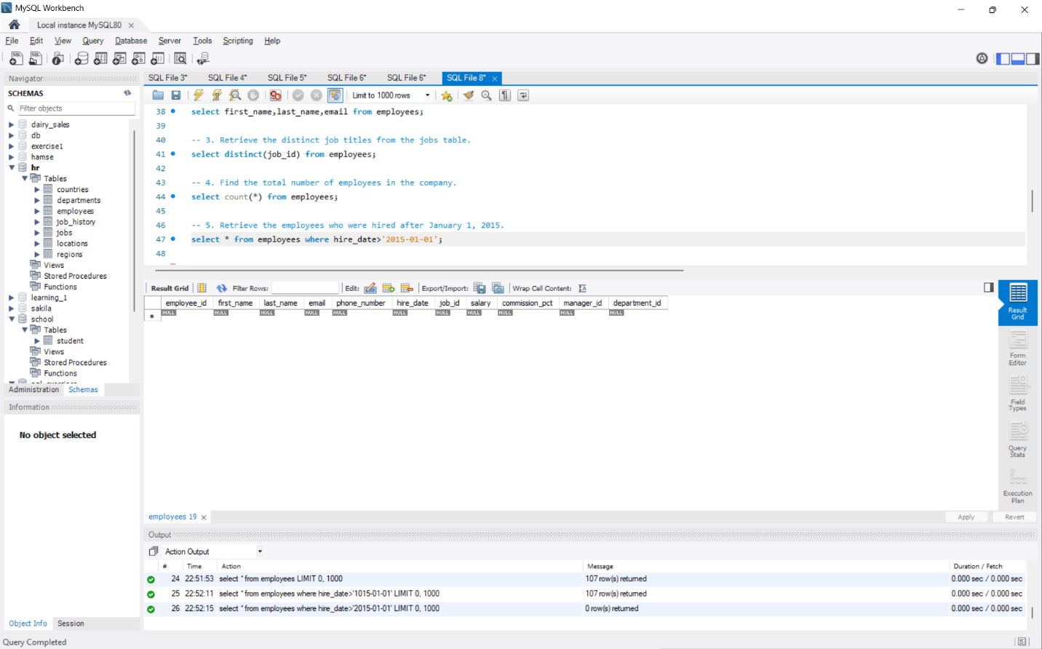

**6. Employees with salary greater than 5000**

**-SELECT * FROM employees WHERE salary > 5000;**

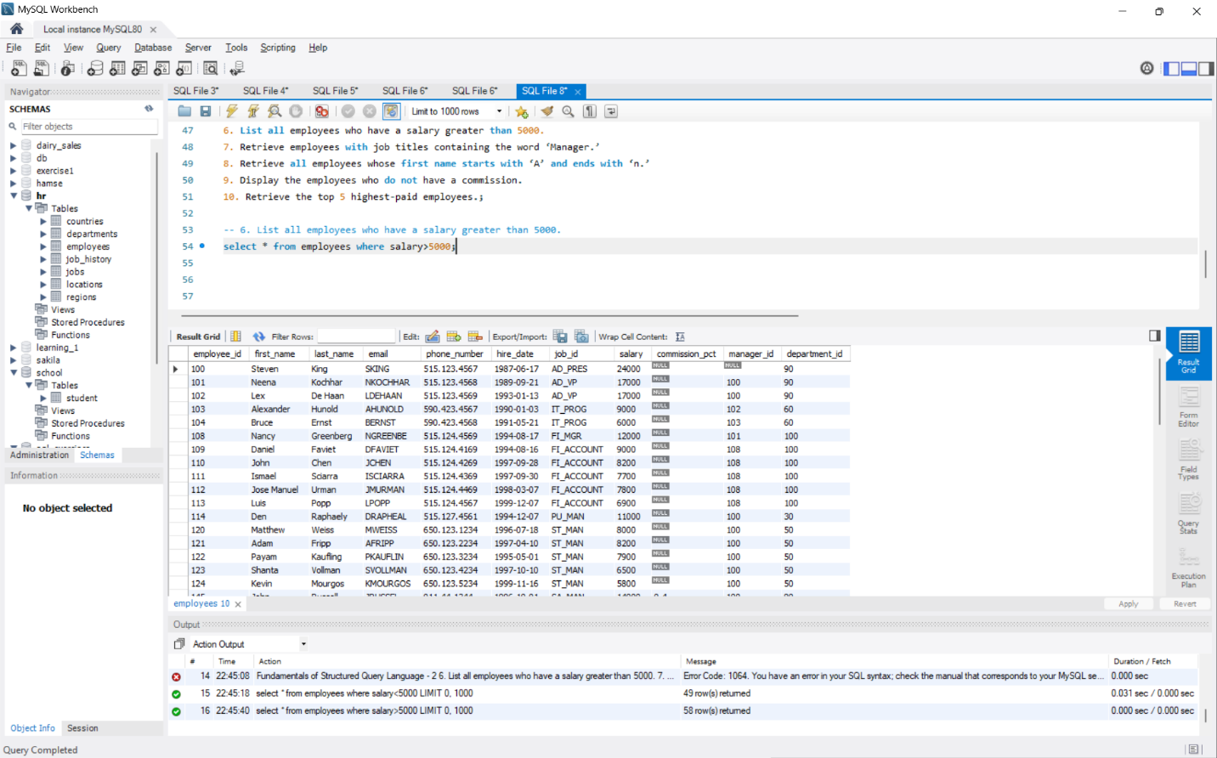

**7. Employees with job titles containing ‘Manager’ -SELECT * FROM employees WHERE job_title LIKE '%Manager%';**

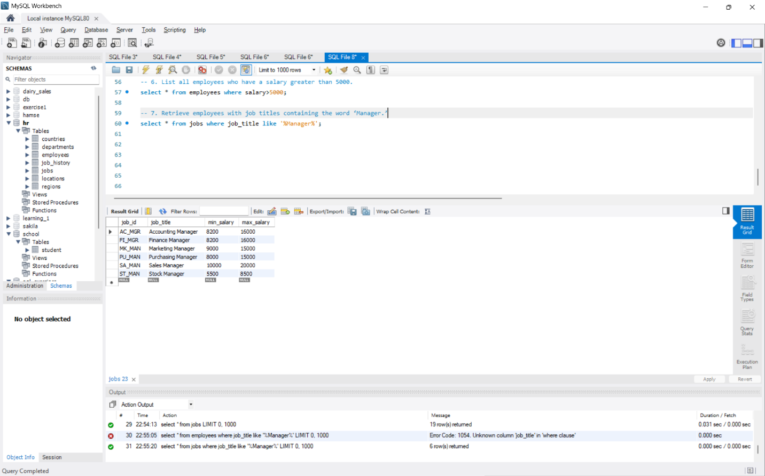

**8. Employees whose first name starts with ‘A’ and ends with ‘n’**

**-SELECT * FROM employees WHERE first_name LIKE 'A%n';**

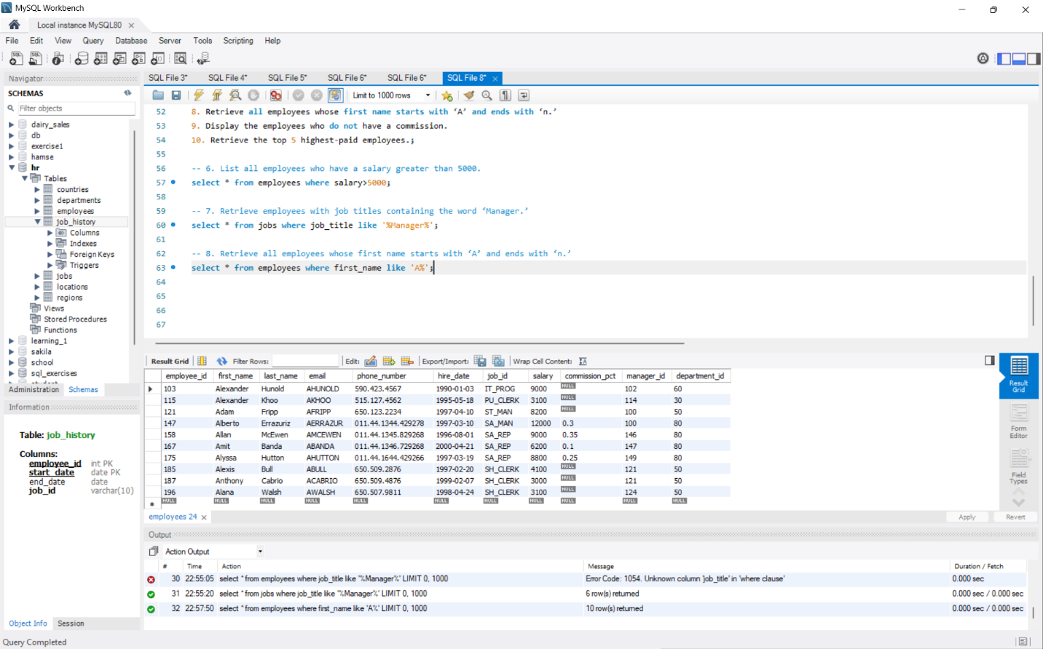

**9. Employees without a commission**

**-SELECT * FROM employees WHERE commission_pct IS NULL;**

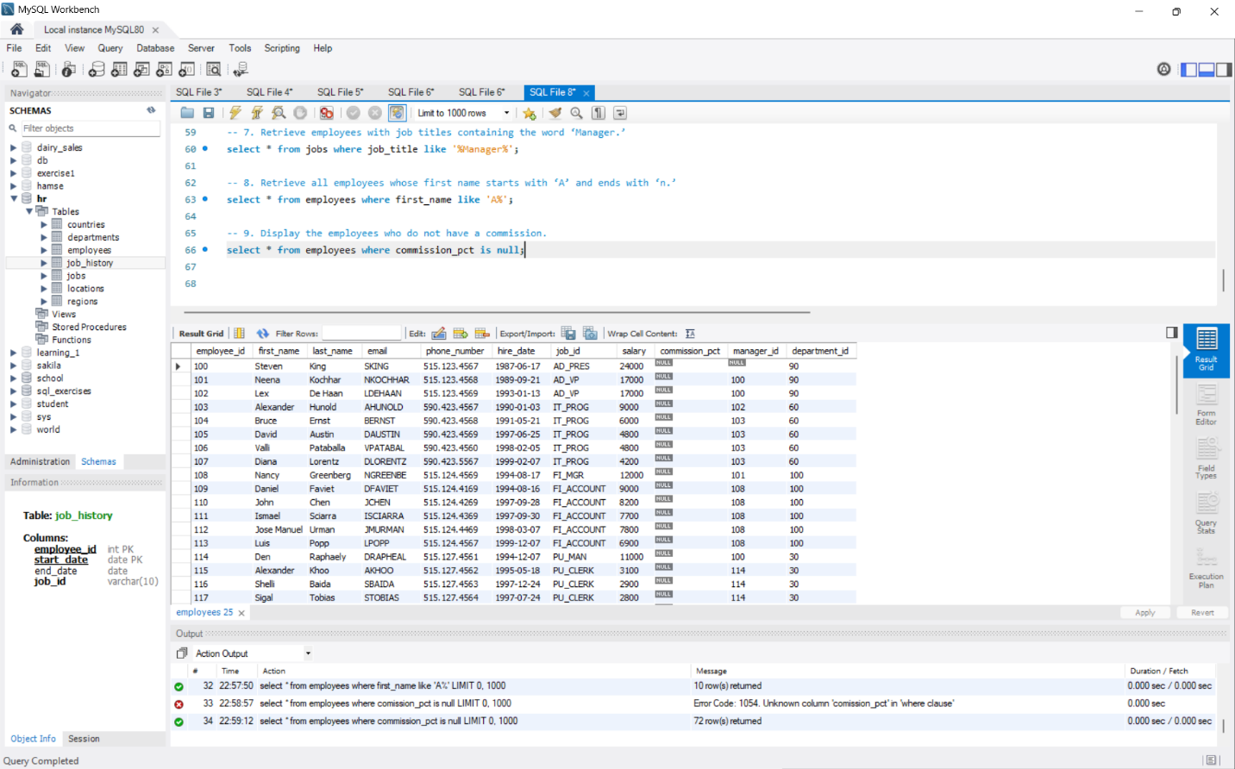

**10. Retrieve the top 5 highest-paid employees**

**-SELECT * FROM employees ORDER BY salary DESC LIMIT 5;**

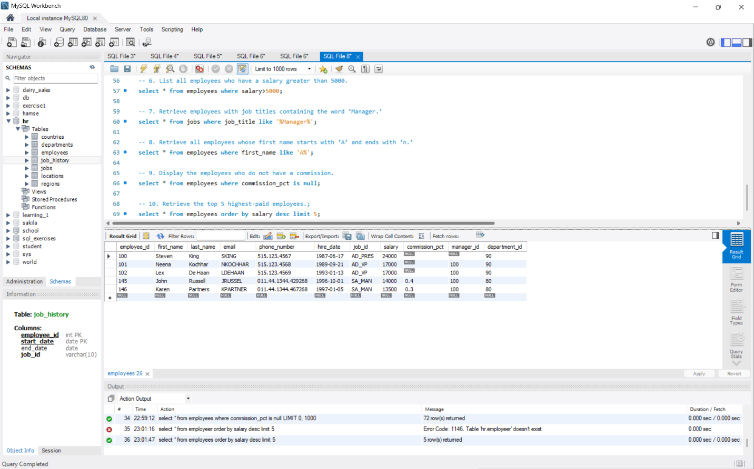

**11. Find the average salary of all employees**

**SELECT AVG(salary) AS average_salary FROM employees;**

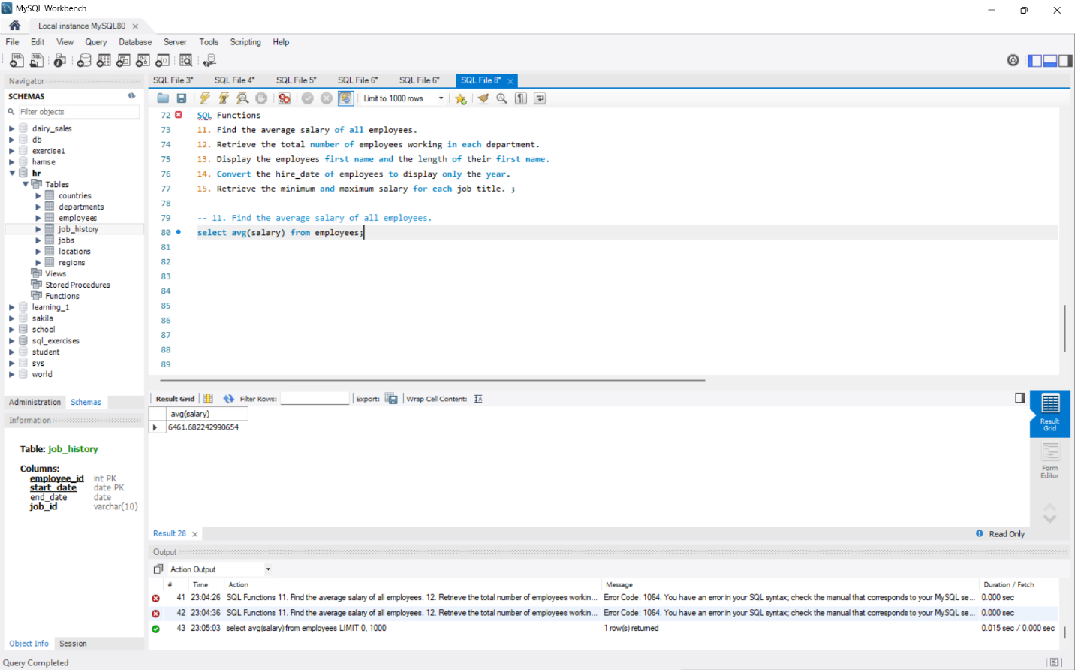

**12. Total employees in each department**

**-SELECT department_id, COUNT(*) AS total_employees FROM employees GROUP BY department_id;**

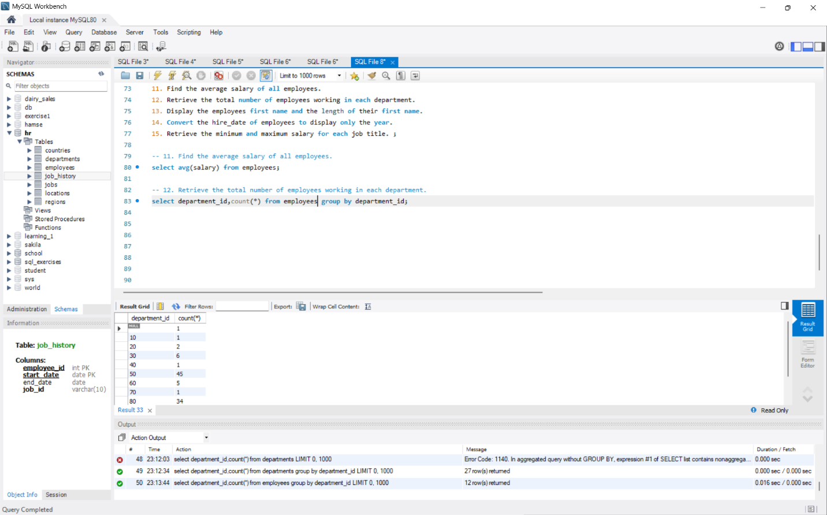

**13. Employee's first name and its length**

**-SELECT first_name, LENGTH(first_name) AS name_length FROM employees;**

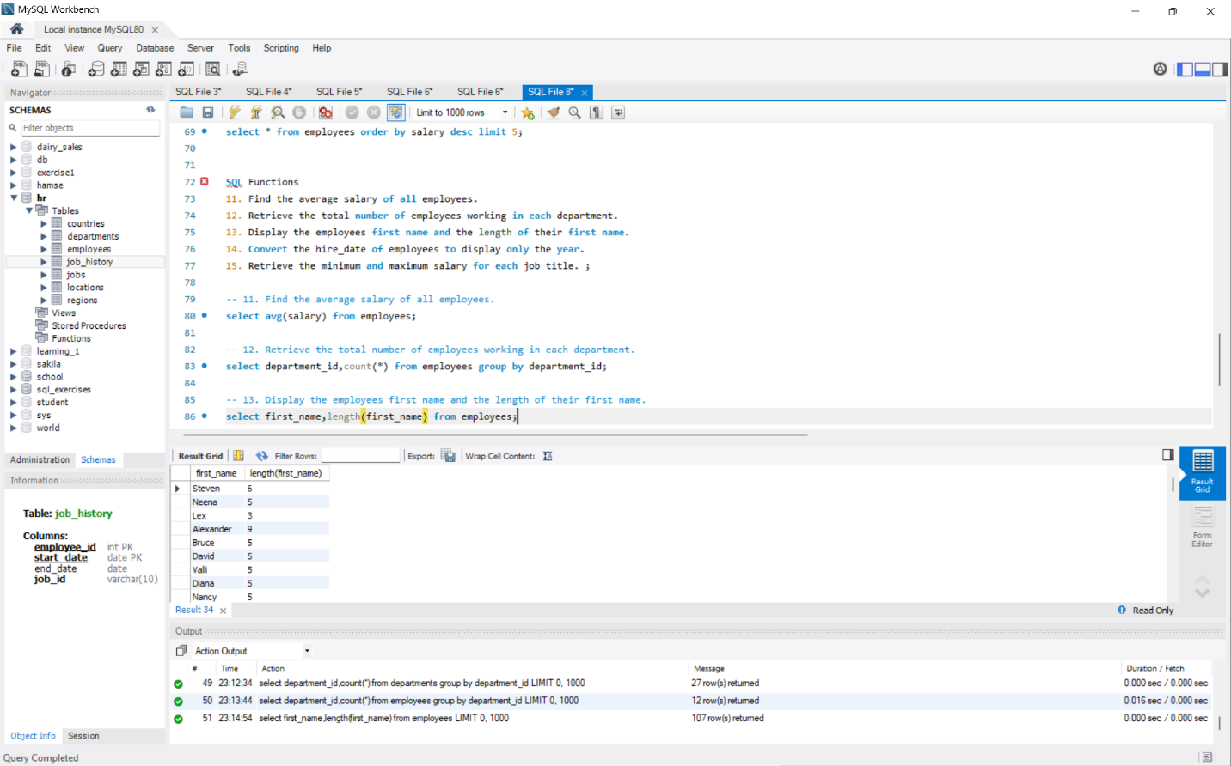

**14. Convert hire_date to display only the year**

**–SELECT first_name, last_name, YEAR(hire_date) AS hire_year FROM employees;**

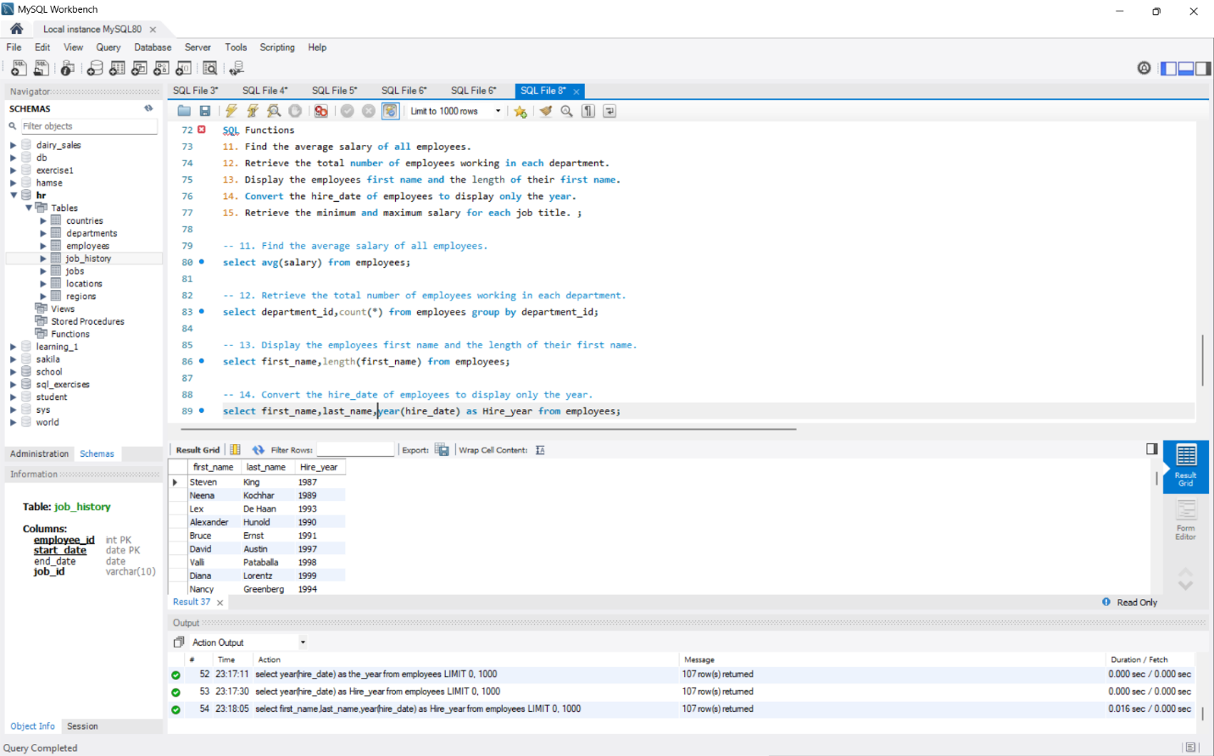

**15. Minimum and maximum salary for each job title**

**-SELECT job_title, MIN(salary) AS min_salary, MAX(salary)**

**AS max_salary FROM employees GROUP BY job_title;**

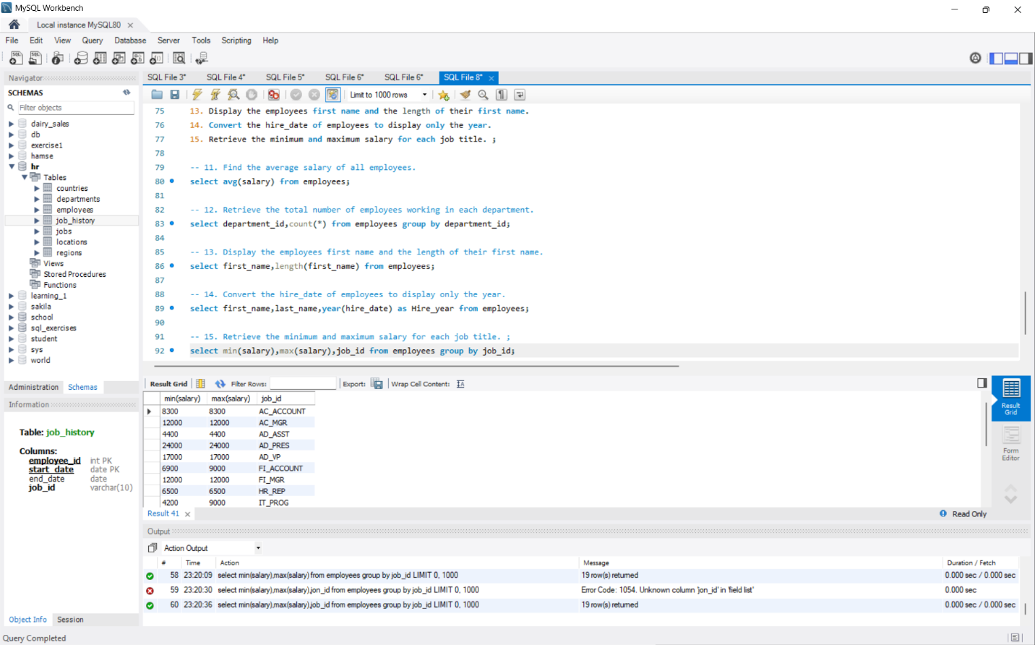

**16. Employees and their department names**

**-SELECT e.first_name, e.last_name, d.department_name**

**FROM employees e**

**JOIN departments d ON e.department_id = d.department_id;**

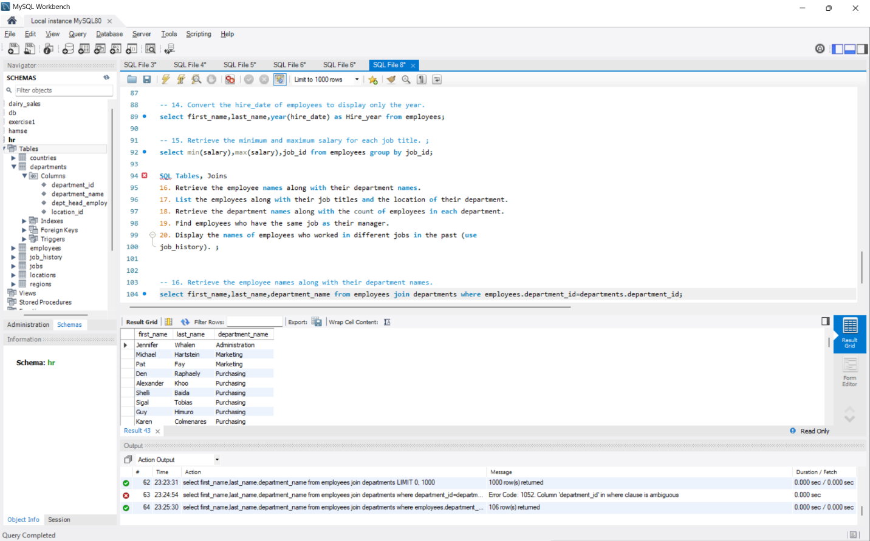

**17. Employees, job titles, and department locations**

**-SELECT e.first_name, e.last_name, j.job_title, l.city**

**FROM employees e**

**JOIN jobs j ON e.job_id = j.job_id**

**JOIN departments d ON e.department_id = d.department_id**

**JOIN locations l ON d.location_id = l.location_id;**

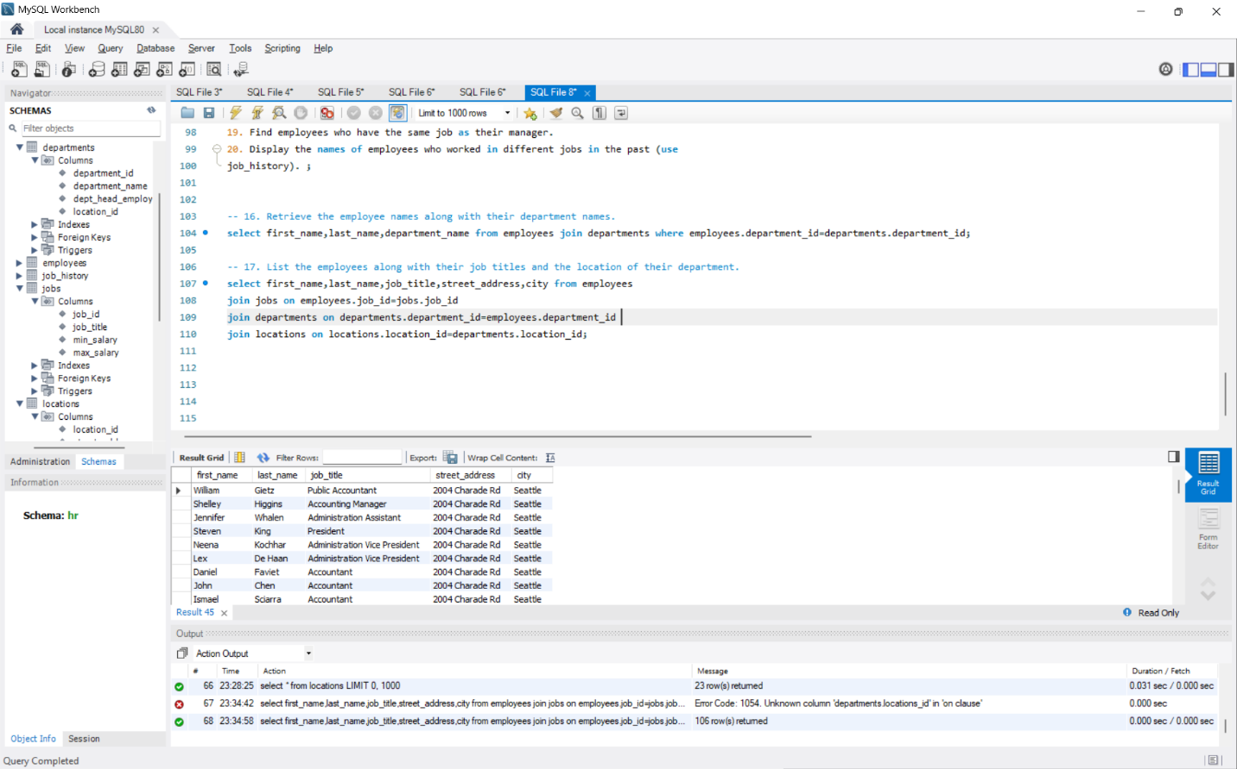

**18. Department names with employee count**

**-SELECT d.department_name, COUNT(e.employee_id) AS employee_count FROM departments d**

**LEFT JOIN employees e ON d.department_id = e.department_id**

**GROUP BY d.department_name;**

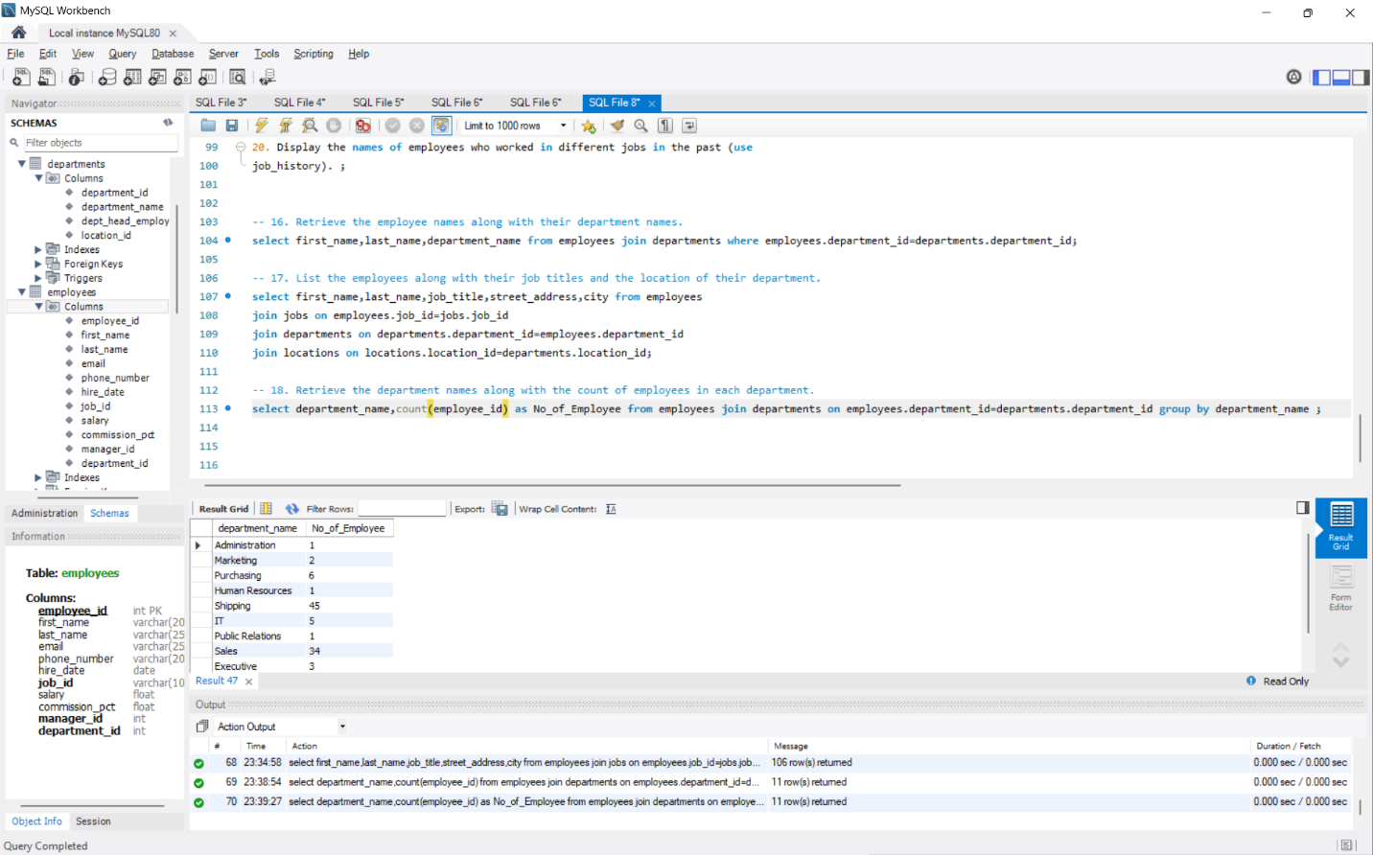

**19. Employees with the same job as their manager**

**-SELECT e.first_name, e.last_name**

**FROM employees e**

**JOIN employees m ON e.manager_id = m.employee_id**

**WHERE e.job_id = m.job_id;**

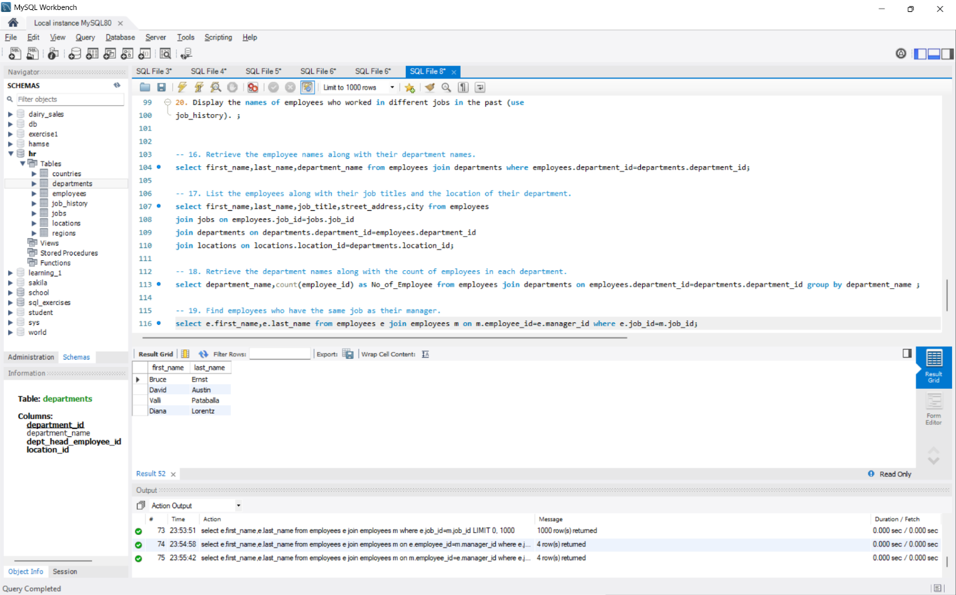

**20. Employees who worked in different jobs in the past**

**-SELECT e.first_name, e.last_name**

**FROM employees e**

**JOIN job_history jh ON e.employee_id = jh.employee_id**

**GROUP BY e.first_name, e.last_name**

**HAVING COUNT(DISTINCT jh.job_id) > 1;**

